Task 1 - 실습 목표 및 허깅 페이스 가입
Created: 2025-03-24 (Mon)
Updated: 2025-03-26 (Wed)

개발자 유미 > 1. 실습 목표 및 허깅 페이스 가입 > 요약

LLM 다운로드를 위한 Hugging face 가입
https://huggingface.co/

사양
$ lscpu
$ free -h
$ nvidia-smi

핸즈온

Hugging face 가입
기존 계정이 있지만, dolpagoo25@gmail.com 계정을 새로 만들었기 때문에 신규 가입을 진행

https://huggingface.co/
- 가입 완료 → https://huggingface.co/dolpagoo25

사양 확인

ChromeBook
thekim@thekim32:~$ lscpu
Architecture: x86_64
CPU op-mode(s): 32-bit, 64-bit
Address sizes: 46 bits physical, 48 bits virtual
Byte Order: Little Endian
CPU(s): 12
On-line CPU(s) list: 0-11
Vendor ID: GenuineIntel
Model name: 12th Gen Intel(R) Core(TM) i5-1245U
CPU family: 6
Model: 154
Thread(s) per core: 1
Core(s) per socket: 1
Socket(s): 12
Stepping: 4
BogoMIPS: 4992.00
Flags: fpu vme de pse tsc msr pae mce cx8 apic sep mtrr pge mca cmov pat pse36 clflush mmx fxsr sse sse2 ss ht syscall nx pdpe1gb rdtscp lm constant_tsc rep_good nopl
xtopology nonstop_tsc cpuid tsc_known_freq pni pclmulqdq vmx ssse3 fma cx16 sse4_1 sse4_2 x2apic movbe popcnt tsc_deadline_timer aes xsave avx f16c rdrand hyp
ervisor lahf_lm abm 3dnowprefetch cpuid_fault ssbd ibrs ibpb stibp ibrs_enhanced tpr_shadow flexpriority ept vpid ept_ad fsgsbase tsc_adjust bmi1 avx2 smep bmi
2 erms invpcid rdseed adx smap clflushopt clwb sha_ni xsaveopt xsavec xgetbv1 xsaves avx_vnni arat vnmi umip pku ospke waitpkg gfni vaes vpclmulqdq rdpid movdi
ri movdir64b fsrm md_clear serialize flush_l1d arch_capabilities
Virtualization features:
Virtualization: VT-x
Hypervisor vendor: KVM
Virtualization type: full
Caches (sum of all):
L1d: 224 KiB (6 instances)
L1i: 320 KiB (6 instances)
L2: 2.5 MiB (2 instances)
L3: 12 MiB (1 instance)
NUMA:
NUMA node(s): 1
NUMA node0 CPU(s): 0-11
Vulnerabilities:
Gather data sampling: Not affected
Itlb multihit: Not affected
L1tf: Not affected
Mds: Not affected
Meltdown: Not affected
Mmio stale data: Not affected
Reg file data sampling: Mitigation; Clear Register File
Retbleed: Not affected
Spec rstack overflow: Not affected
Spec store bypass: Mitigation; Speculative Store Bypass disabled via prctl
Spectre v1: Mitigation; usercopy/swapgs barriers and __user pointer sanitization
Spectre v2: Mitigation; Enhanced / Automatic IBRS; IBPB conditional; RSB filling; PBRSB-eIBRS SW sequence; BHI BHI_DIS_S
Srbds: Not affected
Tsx async abort: Not affected
thekim@thekim32:~$

thekim@thekim32:~$ free -h
total used free shared buff/cache available
Mem: 14Gi 10Gi 606Mi 36Mi 3.6Gi 3.9Gi
Swap: 1.9Gi 5.3Mi 1.9Gi
thekim@thekim32:~$

thekim@thekim32:~$ nvidia-smi
Command nvidia-smi not found
thekim@thekim32:~$

Google Cloud의 VM 생성
Google Cloud는 VM을 생성하기 위한 몇 가지 옵션을 제공
- GCE에서 VM을 생성
- GKE에서 여러 VM의 클러스터를 생성
- Vertex AI에서 Workbench Instance를 생성
가장 간편한 3번 옵션을 선택한다.

• Vertex AI > Workbench Instance를 생성
로컬머신은 GPU가 없으므로, VM을 만들어서 실행해본다.
- 핸즈온은 Task@Google Cloud > Vertex AI로 Workbench Instance를 생성을 참고

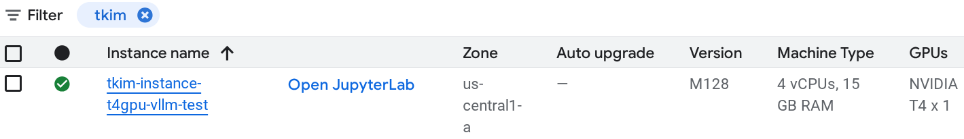Open JupyterLab을 클릭한다.
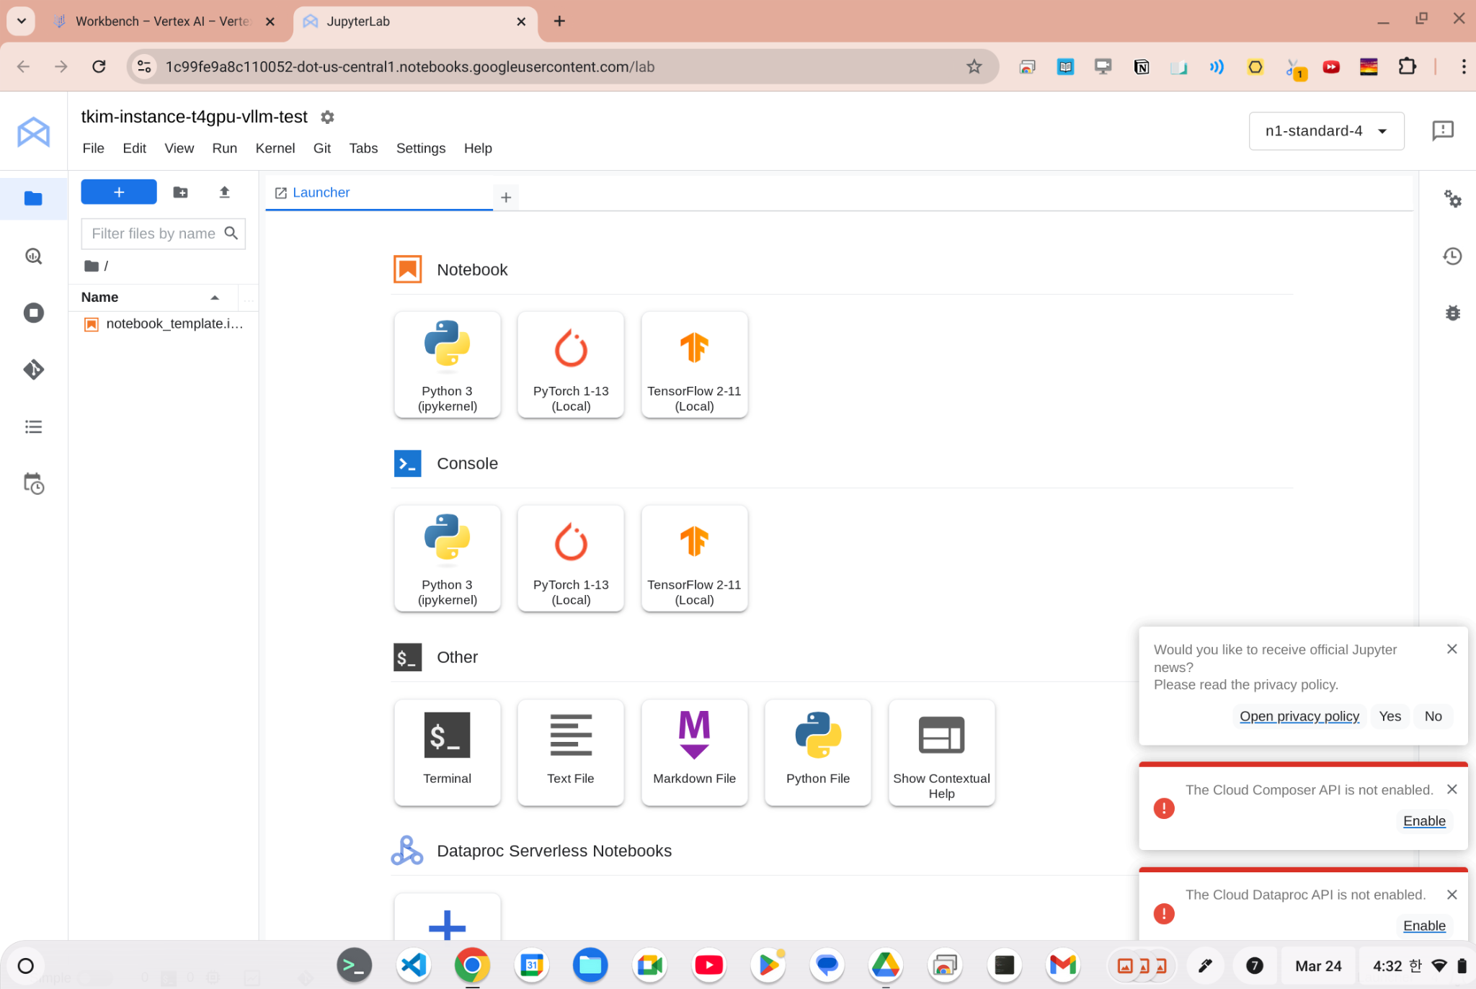

File > Notebook 을 클릭하거나,

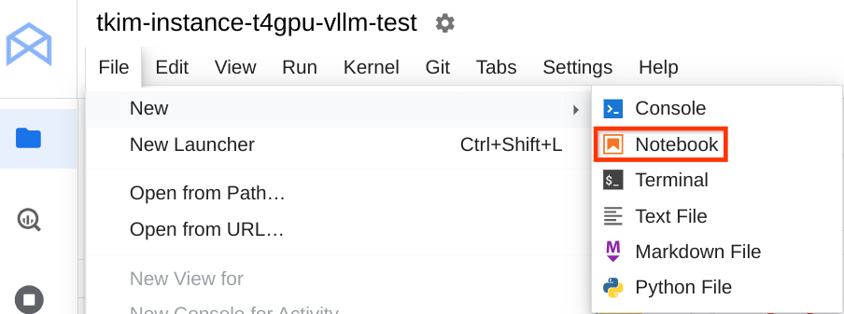

File > Terminal 을 클릭한다.
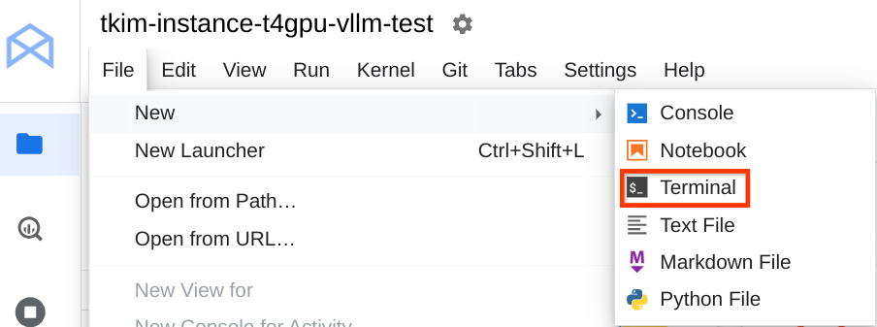
[TODO: delete] https://screenshot.googleplex.com/6pETtCE96dxqJax

Terminal을 실행
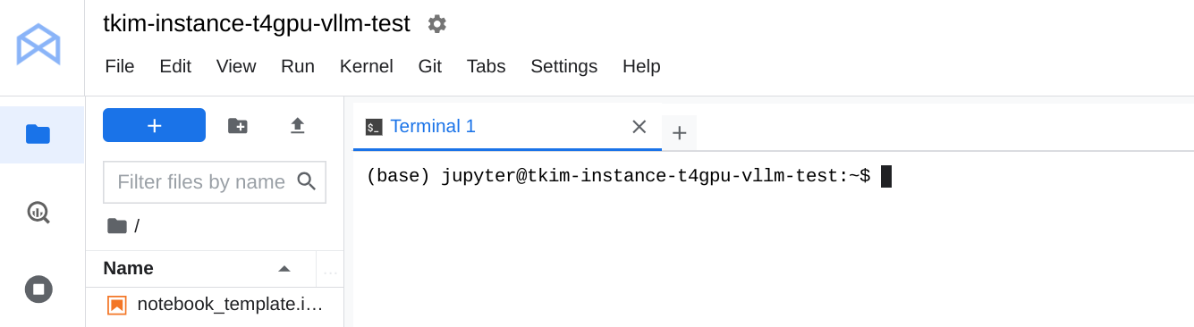
$ lscpu
(base) jupyter@tkim-instance-t4gpu-vllm-test:~$ lscpu

Architecture: x86_64
CPU op-mode(s): 32-bit, 64-bit
Byte Order: Little Endian
Address sizes: 46 bits physical, 48 bits virtual
CPU(s): 4
On-line CPU(s) list: 0-3
Thread(s) per core: 2
Core(s) per socket: 2
Socket(s): 1
NUMA node(s): 1
Vendor ID: GenuineIntel
CPU family: 6
Model: 63
Model name: Intel(R) Xeon(R) CPU @ 2.30GHz
Stepping: 0
CPU MHz: 2299.998
BogoMIPS: 4599.99
Hypervisor vendor: KVM
Virtualization type: full
L1d cache: 64 KiB
L1i cache: 64 KiB
L2 cache: 512 KiB
L3 cache: 45 MiB
NUMA node0 CPU(s): 0-3
Vulnerability Gather data sampling: Not affected
Vulnerability Itlb multihit: Not affected
Vulnerability L1tf: Mitigation; PTE Inversion
Vulnerability Mds: Mitigation; Clear CPU buffers; SMT Host state unknown
Vulnerability Meltdown: Mitigation; PTI
Vulnerability Mmio stale data: Vulnerable: Clear CPU buffers attempted, no microcode; SMT Host state unknown
Vulnerability Reg file data sampling: Not affected
Vulnerability Retbleed: Mitigation; IBRS
Vulnerability Spec rstack overflow: Not affected
Vulnerability Spec store bypass: Mitigation; Speculative Store Bypass disabled via prctl and seccomp
Vulnerability Spectre v1: Mitigation; usercopy/swapgs barriers and __user pointer sanitization
Vulnerability Spectre v2: Mitigation; IBRS, IBPB conditional, STIBP conditional, RSB filling, PBRSB-eIBRS Not affected
Vulnerability Srbds: Not affected
Vulnerability Tsx async abort: Not affected
Flags: fpu vme de pse tsc msr pae mce cx8 apic sep mtrr pge mca cmov pat pse36 clflush mmx fxsr sse sse2 ss h
t syscall nx pdpe1gb rdtscp lm constant_tsc rep_good nopl xtopology nonstop_tsc cpuid tsc_known_freq p
ni pclmulqdq ssse3 fma cx16 pcid sse4_1 sse4_2 x2apic movbe popcnt aes xsave avx f16c rdrand hyperviso
r lahf_lm abm invpcid_single pti ssbd ibrs ibpb stibp fsgsbase tsc_adjust bmi1 avx2 smep bmi2 erms inv
pcid xsaveopt arat md_clear arch_capabilities
(base) jupyter@tkim-instance-t4gpu-vllm-test:~$

$ free -h
(base) jupyter@tkim-instance-t4gpu-vllm-test:~$ free -h

total used free shared buff/cache available
Mem: 14Gi 764Mi 11Gi 0.0Ki 2.4Gi 13Gi
Swap: 0B 0B 0B
(base) jupyter@tkim-instance-t4gpu-vllm-test:~$

$ nvidia-smi
(base) jupyter@tkim-instance-t4gpu-vllm-test:~$ nvidia-smi

Mon Mar 24 07:54:53 2025
+-----------------------------------------------------------------------------------------+
| NVIDIA-SMI 550.90.07 Driver Version: 550.90.07 CUDA Version: 12.4 |
|-----------------------------------------+------------------------+----------------------+
| GPU Name Persistence-M | Bus-Id Disp.A | Volatile Uncorr. ECC |
| Fan Temp Perf Pwr:Usage/Cap | Memory-Usage | GPU-Util Compute M. |
| | | MIG M. |
|=========================================+========================+======================|
| 0 Tesla T4 On | 00000000:00:04.0 Off | 0 |
| N/A 42C P8 9W / 70W | 1MiB / 15360MiB | 0% Default |
| | | N/A |
+-----------------------------------------+------------------------+----------------------+

+-----------------------------------------------------------------------------------------+
| Processes: |
| GPU GI CI PID Type Process name GPU Memory |
| ID ID Usage |
|=========================================================================================|
| No running processes found |
+-----------------------------------------------------------------------------------------+
(base) jupyter@tkim-instance-t4gpu-vllm-test:~$

